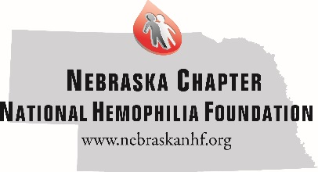
National Conference Funding Guidelines
Each year the Nebraska Chapter of the National Hemophilia Foundation fund travel for its constituents to attend the National Hemophilia’s Foundation’s Annual Meeting. This conference is 4 days and is offered in different locations around the country. Below are the guidelines for providing funding for this opportunity.
Each year the Nebraska Chapter will fund the following Attendees completely (including airfare, hotel, conference registration, ground transportation, baggage fees):
- Two Staff
- One Board Member (and family if affected by a bleeding disorder)
The remaining number of travel grants will be awarded based up the amount the Nebraska Chapter has allotted in their yearly budget, and this amount is discussed and approved by the Advisory Board of Directors.
Travel Grants will be awarded in the following amounts:
Families of 1-4 - $1500
Families of 5-8 - $2500

- Preference will be given to applicants who are 1st Time Attendees (those who have never attended a National Conference)
- Preference will be given to applicants who did not attend the National Conference the previous year.
- Preference will be given to applicants who are actively involved in Nebraska Chapter activities.

Upon receiving a travel grants recipients will be required to do the following:
- Sign & return a receipt stating they received the grant
- Submit receipts for expenses incurred under the travel grant. Only receipts for hotel, airline & conference registration will be accepted.
- Submit to the Chapter a short synopsis of their trip including benefits, things learned, benefit to their children, if applicable.

